

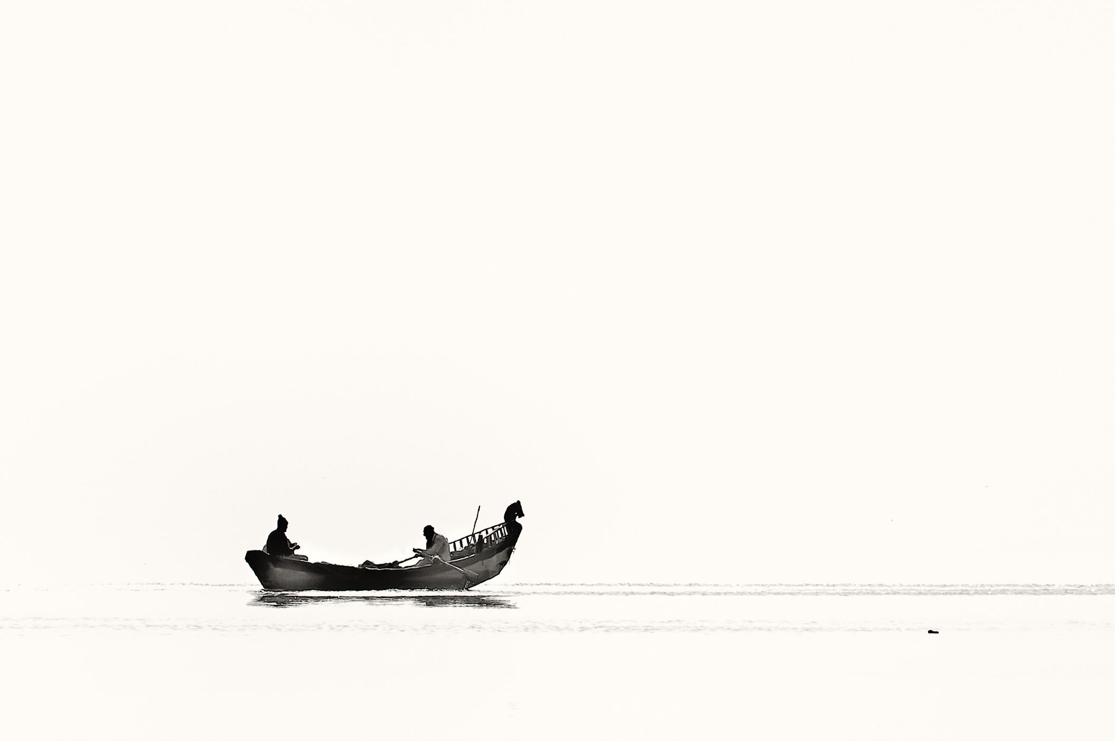

Evaluation Report

ReadySetResource.com

Contents

Introduction 3

Purpose of This Report 3

Project Overview 3

Analysis 3

Design 3

Implementation 3

Testing 3

Installation 3

Other Criteria for Evaluation 3

User Requirements 3

Ease of Maintenance 3

Usefulness of Project Schedule 4

Recommendations 5

Conclusion 5

Bibliography 5

Evaluation Report Work Log 6

# Introduction

ReadySetResource is a website that helps members of staff stay informed and connected to their workplace from the convenience of being anywhere in the world. The project was originally conceived on December of 2016 as I was getting frustrated that there was a poor back-end logistical system in my place at my work. That was put to the back of my mind until summer of 2017 where I decided to pitch the idea to my District and Regional managers. They said that they were enthusiastic to implement the website, but they could not authorise monetary transactions as they did not have the authority.

I decided to continue in my search to find a better way to connect and inform employees and bought a small online file server a few days after. For a few months, I scanned the calendar for that week and uploaded it to the server and in the summer of 2017, it was evident that the solution provided by myself was not good enough. After some brainstorming I came up with ReadySetResource and started thinking of how I can help employees and managers throughout the world that have the same issues that I did at my workplace. In March of this year, I started my project as part of my Graded Unit and this report is the final stage to see if I have managed to complete what I set out to achieve.

(Find the link to my initial proposal [here](Cloud%20Storage%20Facility%20Plan.pdf))

# Purpose of This Report

This report will assess my progress and development throughout the project’s lifespan and will conclude by stating if I believe I have achieved my task, how I have managed myself thought the process and what I have taken from this experience. I used the Kanban methodology and its boards to progress through this project: from the planning to the output, all stages will be analysed to find their merits, flaws and what can be taken from what was done. I will start with an overview of the project in which I will discuss all stages of the program, then dive into each one describing what I did, difficulties I had, how I overcame them and finally how I gained from the experience.

# Project Overview

I decided to break down my project in to five different sections:

* Setup & Analysis - Containing the Project Brief, Task Board, Updated Task Board, Planning Report and thee Software Requirements Specification.
* Design - Containing the Design Specification
* Implementation - Containing my program
* Testing - Containing the Test Plan, Test Strategy, Test Procedure and Test Cases
* Legal, Manuals & Evaluation - Containing the legal documentation, the Requirements Verification and the Evaluation Report.

These five sections are further broken down below to describe what occurred during the stage, the difficulties I had and how

# Analysis

# Design

# Implementation

# Testing

# Installation

**Introduction**

I used GoDaddy for my domain and my hosting and before this project, I did not know how to deploy a web application. Through many hours of YouTube videos, and many tests, published the website online and can now be viewed at readysetresource.com. I encountered several problems when installing the website, the first being that I could not connect to the server. Through much debugging, I found the problem was due to an insecure connection which lead me to find out that the server was rejecting my VPN connection, so I had to turn it off. Another issue I had was that when I uploaded the files, they could not be seen by the browser. I solved this by changing my Linux server to a Windows server.

**Merits**

As said above I never knew how to publish a website and thanks to much perseverance and YouTube, I was able to. This installation process has taught me a lot on how websites work, how servers work and much more which is always

**Flaws**

Security flaws are top priority and my worry is that my testing has not been extensive enough for the live website, so I have deployed the website in beta form with a select group of testers. They will be using the website on a three-month beta programme and provide weekly feedback on any errors.

**Future Benefits**

Learning how to deploy the website has helped me a huge amount and will make it easier for myself in the future to be able to install applications.

# User Requirements

To see a list of all my requirements and if they were completed, please refer to the [Requirements Verification Document](Requirements%20Verification.docx). I decided

Looking back, I understand I had a naïve and unrealistic list of requirements for the timespan provided. I originally hoped to start the project in October and I believe I would have been able to complete most, if not all the requirements, but due to some deliberation the project was started on March. This was a good idea as in October I did not have the knowledge to undergo the project.

# Ease of Maintenance

**Introduction**

Making a program easy to maintain is crucial for future development. This does not matter whether the project will be deployed once or will have multiple releases. I used several methods to improve my project’s ease of maintenance which include white space, breaking down methods in to sub-methods and commenting code.

**Merits**

I found the code much easier to navigate using #regions to hide code that was irrelevant to the task at hand. This helped me by not having to scroll thousands of lines of code and only being able to see the code snipped made sure I didn’t get distracted with other sections of code.

**Flaws**

Sometimes the code could be a bit messy with all the comments and I didn’t read the comments when debugging as much as I wrote them. I believe that sometimes I commented simple code that didn’t need commenting and will need to focus

**Future Benefits**

I believe that my practices are of a good standard and should keep up the level, but I should make more meaningful code that does not clutter the document but still provides useful insights on how the code works.

# Usefulness of Project Schedule

**Introduction**

The project was managed by a Kanban Board on GitHub which was updated regularly throughout the project’s lifecycle. I took advantage of multiple boards, milestones and labels which helped me manage my time efficiently and effectively ensuring that I made submissions on time.

**Merits**

The use of labels was incredibly useful to me as when I was stretched for time I could easily filter my tasks so that I could concentrate on the most important ones. I also believe that milestones were crucial for me to keep time management and found the board to be intuitive and fun to interact with as you could see your progress throughout the lifespan of the project which made it satisfying to close tasks and kept morale high.

**Flaws**

I decided at the start of my project to break down all my stages and create all my tasks for them resulting in over forty Kanban Boards and over two hundred tasks. As I went through the project, I realised that I was having to delete many obsolete tasks which I thought were crucial at the start and I had to create many new tasks. This resulted in lots of wasted time and effort

**Future Benefits**

I believe that in the future I should not micromanage and create all tasks at the analysis stage as the constant evolution of the project made it tedious and time consuming to change tasks, instead the addition of tasks should be ongoing throughout the project’s lifespan. This may make time management harder but will save valuable time.

# Recommendations

For anyone creating this project again, I would recommend to several factors that could have improved my progress throughout the duration of the progress:

* Be ambitious, but not overambitious: Being ambitious and wanting to create great pieces of software is great, but I had the idea to create many applications over multiple platforms and host the website and create an API for the website and create a marketing strategy and sell the website for a monthly subscription fee. It was too much. Although I still want to complete all those tasks, I should’ve realised earlier that I was being overambitious and should have focused on one objective.
* You can always scale up: The reason that big tech companies are always releasing new software or upgrading previous software is because there aren’t enough hours in the day. As the classic quote goes: “Rome wasn’t built in a day”. I took on a huge work load that I could not fulfil in the timescale provided and I should have been more realistic.

# Conclusion

These past few months have been intense, but I wouldn’t have been where I am now having learnt all that I have without this project. I believe that even though I was being overambitious in the beginning, I developed myself and my project and I am proud with what I have achieved. Looking forward I need to keep learning more as that will ensure I can provide the best product for any user of a system built by myself.

# Bibliography

# Evaluation Report Work Log

| Entry | Description | Person | Date | Mins Spent |
| --- | --- | --- | --- | --- |
| 1 | Formatted the document | Aidan Marshall | 31/3/18 | 13 |
| 2 | Wrote the usefulness of project schedule | Aidan Marshall | 31/3/18 | 48 |
| 3 | Computer crashed | Aidan Marshall | 31/3/18 | 3 |
| 4 | Wrote the usefulness of project schedule | Aidan Marshall | 31/3/18 | 48 |
| 5 | Started my recommendations | Aidan Marshall | 31/3/18 | 28 |
| 6 | Started my ease of maintenance | Aidan Marshall | 31/3/18 | 34 |
| 7 | Wrote the conclusion | Aidan Marshall | 31/3/18 | 23 |
| 8 |  |  |  |  |
| 9 |  |  |  |  |
| 10 |  |  |  |  |
| 11 |  |  |  |  |
| 12 |  |  |  |  |
|  |  |  |  |  |
|  | | | | |